Student & Internship Details

Student Name | Vinayak Dubey
Programme & Batch | PGDM | Batch 2025-27
Organization Name | Negbuy Private Limited
Industry / Sector | Procurement & Supply Chain
Internship Duration | 12 weeks
Faculty Supervisor | Dr. Gunjan Sood
Organizational Supervisor | Mr. Sayeem Salmani
Date of Submission | 22nd June, 2026

Section 1 — Problem Statement
1.1 What is the problem? Who does it affect, and how?
During the internship at Negbuy, it was observed that the procurement team regularly receives RFQs in different unstructured formats such as screenshots, product images, PDFs, Excel sheets, WhatsApp messages, and technical descriptions. Before supplier sourcing can begin, procurement personnel manually review these RFQs to identify part numbers, manufacturers, specifications, and product details.
A major issue within the current workflow is that procurement information and supplier references are not maintained through a centralized system. As a result, procurement personnel often repeat the same supplier search and quotation activities even for similar RFQs. This increases manual effort, slows down procurement execution, and makes supplier tracking difficult.
The problem mainly affects procurement interns, sourcing executives, and supply chain personnel who are directly involved in supplier identification, quotation handling, and RFQ management activities.

1.2 How is this problem currently being solved (without AI)?
At present, the entire RFQ handling and sourcing process is managed manually. The procurement team receives RFQs through email, WhatsApp, spreadsheets, screenshots, and product photographs. Team members manually extract part numbers and manufacturer details before searching for suppliers on Alibaba, Google, and distributor websites.
For standard industrial products, supplier sourcing is generally done through Alibaba and similar platforms. For specialized industrial and turbine spare parts, procurement personnel manually identify suppliers through Google searches and send RFQs through email for quotation requests and follow-ups.
Quotation details and supplier responses are then manually organized in Excel sheets or Google Sheets for comparison and coordination with the sales team. Since historical RFQ records and supplier information are not centrally maintained, retrieving previous sourcing information becomes difficult and time-consuming.

1.3 Why is AI a viable solution for this problem?
The identified problem is largely related to repetitive information handling and procurement data organization. Procurement personnel spend considerable time manually extracting information from RFQs, identifying products from images, organizing quotation details, and maintaining procurement records.
AI can support this workflow by assisting in RFQ interpretation, image-based product identification, information extraction, and procurement database organization. An AI-assisted system can help structure procurement information into a searchable format, reduce repetitive manual work, improve RFQ tracking, and support faster retrieval of supplier and quotation history during sourcing activities.

1.4 When did you identify this problem, and who confirmed it was real?
The problem was identified during the initial phase of the internship while handling live RFQs, supplier sourcing activities, quotation comparisons, and follow-up coordination tasks. The repetitive nature of supplier searching, manual RFQ interpretation, and fragmented procurement information handling became consistently visible during daily operations.
The issue was further discussed with Mr. Sayeem Salamani, Supply Chain Manager, who confirmed that repetitive sourcing activities, lack of procurement information organization, and supplier tracking difficulties are ongoing operational challenges within the current procurement workflow.

Section 2 — Your AI Solution
2.1 What did you build? Describe the solution in plain language.
The proposed solution developed during the internship is titled ProcureIQ, an AI-assisted procurement information management system designed to support RFQ interpretation and procurement data organization at Negbuy.
The system is intended to address the operational inefficiencies caused by manual RFQ interpretation and the absence of a centralized procurement information repository. At present, procurement personnel receive RFQs in multiple formats including screenshots, PDFs, Excel sheets, product photographs, technical specification documents, email attachments, and text messages. Each RFQ must be manually interpreted to identify the manufacturer, part number, technical specifications, and quantity before supplier sourcing activities can begin.
ProcureIQ is designed to simplify this process by reading RFQs directly in whatever format they are uploaded. Once the RFQ is uploaded, the system extracts key procurement information including:
- Manufacturer name
- Part number
- Product description
- Technical specifications
- Quantity required
- Product category
After extraction, the information is converted into a structured format and stored inside a centralized procurement database. The database is designed to support future retrieval and procurement reference activities.
The system also includes a search functionality through which procurement personnel can retrieve historical RFQ records using:
- Manufacturer name
- Part number
- Product keyword
- Technical reference
For example, if a procurement executive searches for “Siemens,” the system should display all previously stored Siemens-related RFQs and associated procurement information. Similarly, if a specific part number is searched, the system should retrieve all procurement records related to that part number.
The primary objective of ProcureIQ is not procurement automation, but procurement information management and retrieval support. The system is intended to reduce repetitive sourcing effort, improve procurement memory retention, and support faster procurement coordination activities.

2.2 What tools or platforms did you use to build it?
Tool / Platform Used | What It Was Used For
Bolt.new | Building and deploying the web application prototype
React.js | Front-end application development
JavaScript | Application logic and data processing
HTML/CSS | User interface design and styling
Claude AI | Prototype development support and debugging
ChatGPT | Solution design, workflow logic, testing support, and documentation
Browser Storage | Storing RFQ records within the prototype database
Rule-Based Extraction Engine | Extracting procurement information from RFQs without paid APIs
CSV Export Module | Exporting procurement records for analysis and reporting
2.3 What data or documents did the solution use?
The solution used RFQs received during procurement sourcing activities at Negbuy. These included screenshots, product photographs, PDF files, Excel sheets, technical specification documents, email attachments, and plain text RFQ messages. Sample procurement RFQs related to industrial spare parts, automation components, turbine equipment, and supplier quotations were analyzed during the development stage. The solution also utilized manually interpreted RFQ data for testing extraction accuracy and validating the procurement information structure.

2.4 What does the solution produce as its output?
The solution produces structured procurement information from unstructured RFQ inputs. The output includes manufacturer name, part number, quantity, technical specifications, product description, and RFQ category. This information is automatically arranged into a centralized database format using Google Sheets. The system also supports basic search and retrieval functionality, allowing users to search previous RFQs using manufacturer names, part numbers, or product descriptions. The output helps reduce repetitive manual interpretation and improves procurement data accessibility.

2.5 What are the limitations of your solution?
The current version of ProcureIQ is limited to procurement information extraction and database organization. The system does not currently automate supplier sourcing, quotation comparison, supplier communication, or procurement decision-making activities.
The project also depends on the quality and readability of incoming RFQ formats. Poor image quality, incomplete technical specifications, or unclear product references may reduce extraction accuracy.
At the current internship stage, the system remains a prototype-level solution and has not yet been deployed at organizational scale. Historical procurement data access is also limited because the internship primarily relies on live RFQs received during the internship period.
The current prototype is additionally dependent on external AI APIs and internet-based extraction systems. Full organizational deployment would require:
- Secure database integration
- Internal procurement data permissions
- Larger RFQ training datasets
- Better retrieval architecture
- Dedicated system hosting infrastructure
Future development may include quotation tracking, supplier history mapping, supplier scoring systems, and procurement analytics dashboards, but these capabilities remain outside the current project scope.

Section 3 — Deployment
3.1 Which deployment level did you achieve?
Level | Description | Did you achieve this?
1 | Demonstrated in context — shown to supervisor or team member | Yes
2 | Team-level use — at least one other person used it during the internship | No
3 | Organizationally adopted — continued use confirmed beyond your internship | No

3.2 Describe how you deployed or demonstrated the solution.
ProcureIQ was demonstrated in person to Mr. Sayeem Salmani, Supply Chain Manager at Negbuy Private Limited. The demonstration was conducted using actual RFQs received during procurement operations at Negbuy. The prototype was developed based on approximately 24 RFQs collected during the internship, and a database containing 10 RFQ records was created for testing purposes. Eight RFQs were tested by the student during development, while two additional RFQs were reviewed during the demonstration session.
During the demonstration, the complete workflow was presented, including RFQ upload, information extraction, centralized database creation, search functionality, and retrieval of procurement records. The RFQ upload interface, extraction results, database screen, search functionality, and the complete upload-to-storage process were demonstrated. The session lasted approximately 10–12 minutes, including feedback and discussion regarding the solution's strengths and limitations.

3.3 If you did not reach Level 2 or 3, explain why.
The solution remained at Level 1 because the current prototype has limitations in processing image-based RFQs. While the system can process text-based RFQs and structured procurement information, it currently lacks a fully integrated image recognition and OCR (Optical Character Recognition) capability required to automatically extract information from product photographs, packaging labels, screenshots, and engraved part numbers.
A significant portion of RFQs received by Negbuy are submitted as product images. Since the prototype cannot yet reliably identify manufacturer names, part numbers, and technical specifications directly from images, manual intervention is still required. Due to these limitations, the solution was demonstrated and evaluated but was not considered ready for team-level or organizational deployment during the internship period.

3.4 What would be required for the solution to be deployed more broadly?
To support wider deployment, ProcureIQ would require integration of advanced OCR and image-recognition capabilities to automatically extract procurement information from product photographs, labels, screenshots, and engraved component markings. Additional testing using larger RFQ datasets would be required to improve extraction accuracy and reliability.
The solution would also benefit from a cloud-based database architecture, enhanced user management features, expanded testing with procurement personnel, and management approval before operational deployment. These improvements would allow ProcureIQ to evolve from a proof-of-concept prototype into a practical procurement information management system.

Section 4 — Organization Response
4.1 Who at the organization saw or used your solution?

Name / Role | How They Engaged | Their Observation
Mr. Sayeem Salmani, Supply Chain Manager | Reviewed the prototype during an in-person demonstration using actual Negbuy RFQs. Observed the RFQ upload interface, extraction results, database management, search functionality, and complete workflow from upload to storage. | Appreciated the concept of a centralized procurement database and recognized its potential for procurement information management. However, he identified image-based RFQ extraction as a major limitation that would need to be addressed before practical organizational use.
Mr. Hemant, Team Leader | Reviewed the prototype and observed the dashboard, RFQ database, search functionality, dark/light mode, and export-to-CSV feature during the demonstration. | Appreciated the user interface, database organization, dashboard KPIs, and export functionality. Suggested adding a professional logo and further improving the system for future use by interns and procurement staff.

4.2 What did they say about it?
Mr. Sayeem Salmani (Supply Chain Manager) provided the following feedback during the demonstration:
"Since it is not able to read the image, how will you work on this? A lot of RFQs come as product images. If the AI cannot identify the part number and product details from images automatically, users will still have to enter information manually. Your AI is not able to read the image and extract the product number or part number mentioned there. Then it is of no use because almost 50% of the RFQs are received as images and the remaining 50% are received as text, PDF files, or table formats. Maybe in the future, after you improve the user interface and solve the image-reading problem, it can become useful as an RFQ database management tool."

Mr. Hemant (Team Leader) provided the following feedback during the demonstration:
"I liked the interface and the way you have organized everything. The dark and light mode looks good, and the dashboard gives a quick idea about the RFQs, pending records, and quoted records. The database section is easy to understand, and the export-to-CSV feature is useful. You're just an intern and you're already making things like this, which is really good. With some more improvements, especially in image reading and extraction, you can make this complete. I think it can be helpful for other interns in the future because they won't have to search for old RFQs again and again. Also maybe design the logo, it will make it look more professional and complete."

4.3 Did the organization express interest in continuing to use or develop the solution?
Yes, the feedback received during the demonstration was generally positive. Both Mr. Sayeem Salmani (Supply Chain Manager) and Mr. Hemant (Team Leader) appreciated the concept of creating a centralized procurement information database that could organize RFQs and make historical procurement information easier to retrieve.
Mr. Salmani acknowledged that the solution addresses a genuine operational challenge related to procurement information management and repetitive RFQ handling. However, he noted that the current prototype would require improvements in image recognition and extraction capabilities before it could be considered for wider organizational use.
Mr. Hemant provided positive feedback on the overall interface, dashboard structure, database organization, search functionality, and export features. He also commented that the solution could become useful for future interns by reducing the need to repeatedly search for historical RFQs and procurement information.
Overall, while the organization did not formally adopt the prototype during the internship period, both reviewers recognized its potential value and encouraged further development to improve its practical usability and deployment readiness.

4.4 What would you do differently if you had more time?
If additional time were available, the primary focus would be integrating OCR and image-recognition technology capable of reading product labels, packaging stickers, screenshots, and engraved part numbers directly from RFQ images. This was identified as the most significant limitation during testing and demonstration.
Additional improvements would include increasing the RFQ testing dataset, enhancing extraction accuracy, improving the user interface, strengthening database functionality, and implementing a cloud-based architecture for centralized access. These enhancements would address the key concerns raised during the organizational review and improve the solution's readiness for practical deployment.

ProcureIQ
1. Solution Logic
The system accepts RFQs in multiple formats including screenshots, product photographs, PDFs, Excel files, and plain text. ProcureIQ extracts key information such as manufacturer, part number, quantity, product category, and technical specifications. The extracted information is then organized into a centralized procurement database where users can search, filter, retrieve, and export records.

2. Prototype / Working Model
A functional prototype was developed using React-based web application architecture. The prototype consists of:
- RFQ Upload Module
- AI Extraction Module
- Procurement Database Module
- Search and Filter Functions
- Export Functionality
- Dark Mode / Light Mode Interface
The prototype demonstrates the complete workflow from RFQ upload to database storage and retrieval.
3. Build Notes
The prototype was developed using:

Component | Technology Used
User Interface | React.js
Application Logic | JavaScript
Styling | HTML/CSS
Development Platform | Bolt.new (browser-based app builder)
Design Support | Claude AI & ChatGPT
Data Storage | Browser Storage (Prototype Database)
The system was designed as a proof-of-concept for future organizational deployment.
How It Was Built

Item | Detail
Platform used | Bolt.new (browser-based app builder)
Frontend framework | React.js
AI extraction engine | Free extraction mode (rule-based + pattern matching, no paid API required)
Database | In-app structured database with 15 real Negbuy RFQ records pre-loaded
Deployment | Live hosted at https://react-app-creation-74d5.bolt.host

5. Input–Output Flow
Input
- Product photographs
- Screenshots
- RFQ text
- PDF files
- Excel spreadsheets
- Email content
Processing
- RFQ interpretation
- Data extraction
- Field classification
- Record generation
Output
- Manufacturer
- Part Number
- Quantity
- Product Category
- RFQ Format
- Status
- Supplier Information
- Searchable Database Record
Example:
Input:
A5E37876282, - 1 No.
A5E34621797072, - 3 Nos.
Make- Siemens
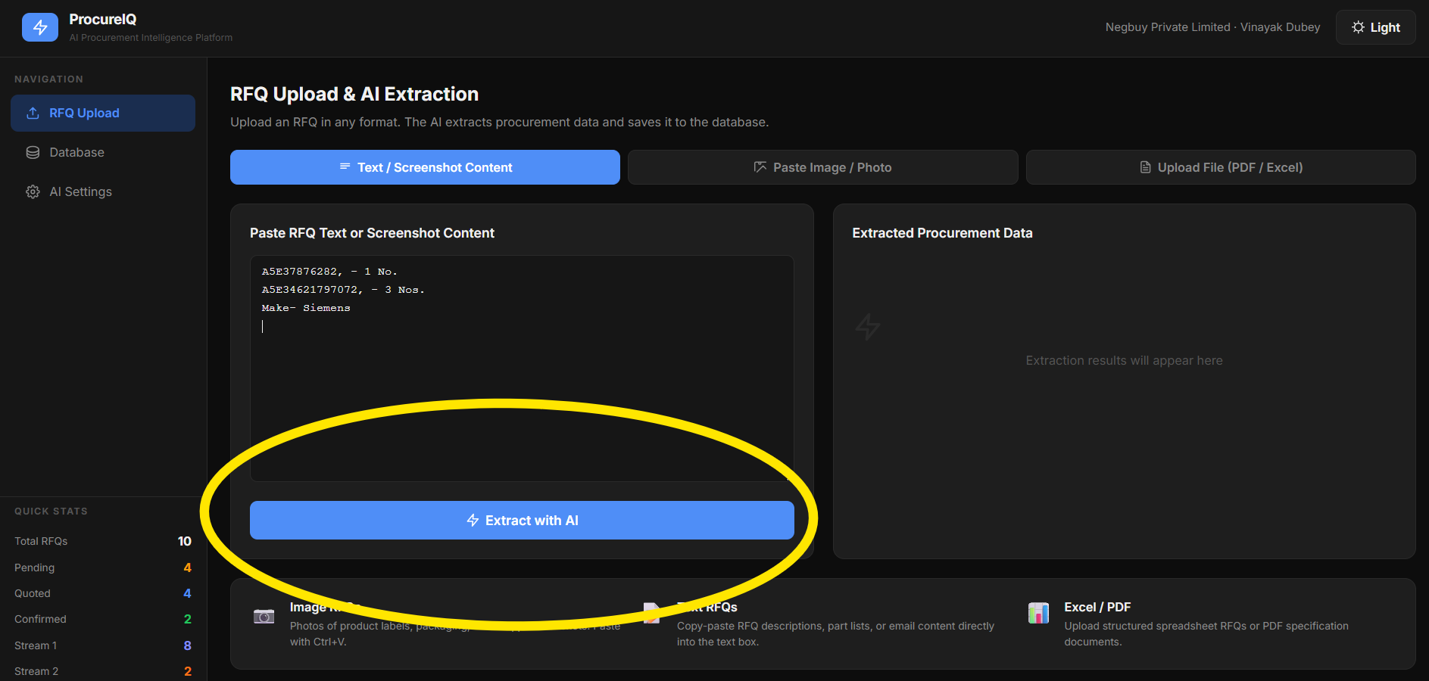

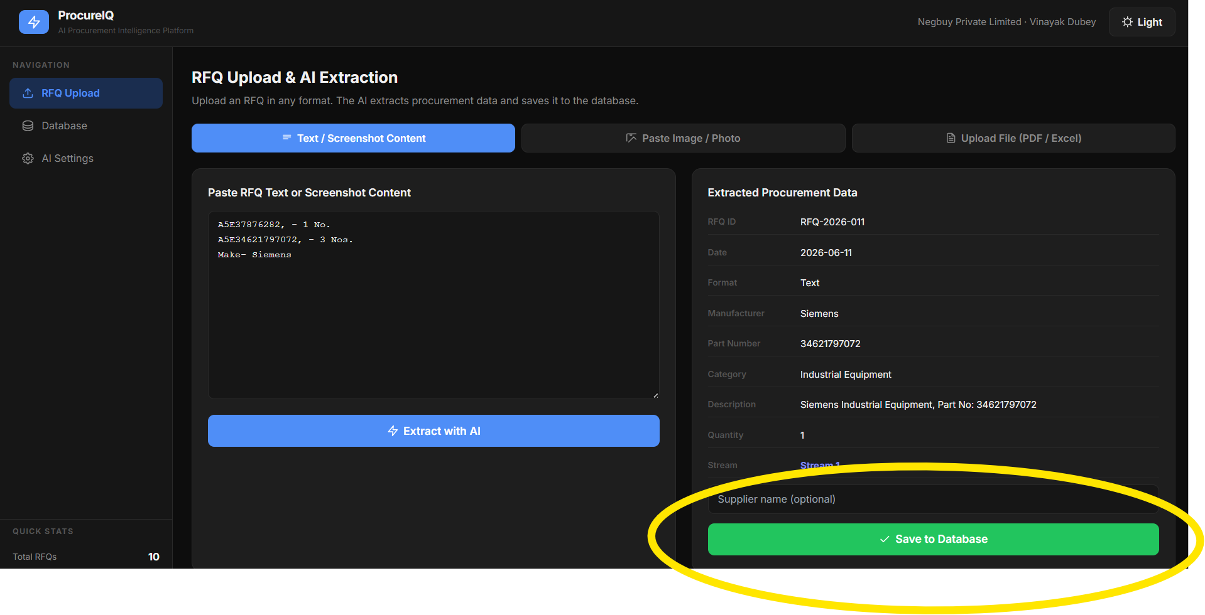

Output: When you go to Database option, you can see the 1st entry. The AI analyzed and entered accordingly.
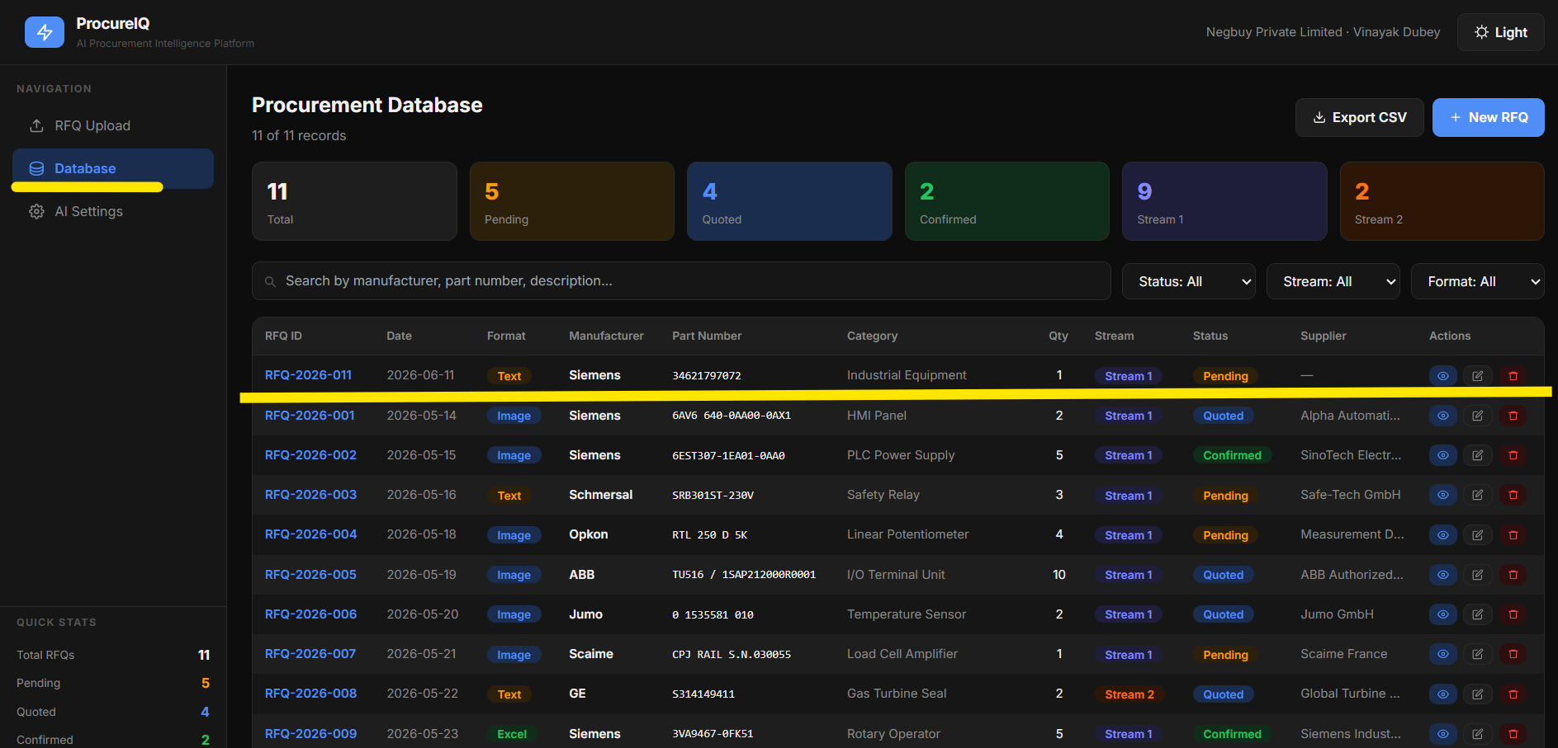

6. Basic Testing Evidence
Testing was conducted using sample RFQs collected during the internship. The system was tested using RFQs received in text, screenshot, image, PDF, and spreadsheet formats.
The prototype successfully:
- Accepted multiple RFQ formats
- Generated structured procurement records
- Stored records in a centralized database
- Enabled search and filtering functionality
- Allowed export of procurement data
The testing confirmed the feasibility of using AI-assisted procurement information management to improve RFQ handling and procurement data organization at Negbuy.

